Performance Essay Hints
- A ramp makes an incline of $37°$ with the ground. The length of the incline ramp is 27 inches. Find the horizontal length of the base of the ramp and the vertical height of the ramp.

- Solve the following equation using the method of your choice. Make sure to review ALL methods of solving quadratics (square root method, factoring, completing the square, and quadratic formula.

- Give an example of each of the following:
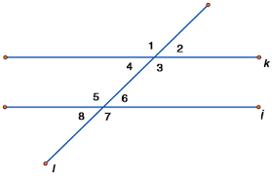
  - Same-side interior angles
  - Alternate interior angles
  - Alternate exterior angles
  - Corresponding angles
  - Vertical angles
  - Linear Pair

- Graph the following function and label all of its parts (everything we’ve done in class!)
$$y=-{\left(x-3\right)}^{2}+4$$

Performance Essay Hints
- A ramp makes an incline of $37°$ with the ground. The length of the incline ramp is 27 inches. Find the horizontal length of the base of the ramp and the vertical height of the ramp.

- Solve the following equation using the method of your choice. Make sure to review ALL methods of solving quadratics (square root method, factoring, completing the square, and quadratic formula.

- Give an example of each of the following:
  - Same-side interior angles
  - Alternate interior angles
  - Alternate exterior angles
  - Corresponding angles
  - Vertical angles
  - Linear Pair

- Graph the following function and label all of its parts (everything we’ve done in class!)
$$y=-{\left(x-3\right)}^{2}+4$$

